CS 6375
ASSIGNMENT 1

Names of students in your group:
Shisir Humagain

Number of free late days used: __0__
Note: You are allowed a total of 4 free late days for the entire semester. You can use at most 2 for each assignment. After that, there will be a penalty of 10% for each late day.

Please list clearly all the sources/references that you have used in this assignment.
- Google Gemini for Gradient Descent code

1. Introduction
The objective of this assignment was to implement linear regression using gradient descent and compare it with Scikit-Learn's SGDRegressor implementation. The Auto MPG dataset from the UCI Machine Learning Repository was selected because it is a regression dataset with both numerical and categorical features.

2. Dataset Description
Dataset: Auto MPG
Target Variable:
- MPG (Miles Per Gallon)
Number of Samples:
- 392 records after preprocessing
Features:
- Cylinders
- Displacement
- Horsepower
- Weight
- Acceleration
- Model Year
- Origin

3. Data Preprocessing
The following preprocessing steps were performed:
- Removed duplicate records.
- Removed missing values.
- Converted categorical variables into numerical values.
- Standardized all feature variables using StandardScaler.
- Split data into 80% training and 20% testing sets.

4. Part 1: Custom Gradient Descent Implementation
Algorithm
Linear Regression was implemented from scratch using vectorized gradient descent.
Weight Update Equation:
W = W − α∇J(W)
Cost Function:
J(W) = (1/2m) Σ(h(x) − y)²
Hyperparameter Tuning
The following combinations were tested:
Learning Rates:
- 0.001
- 0.005
- 0.01
- 0.05
Iterations:
- 1000
- 3000
- 5000
Results for all trials were stored in:
gradient_descent_tuning_log.csv
Best Parameters
Learning Rate: 0.05
Iterations: 10000
Best Training MSE: 10.979255842373474
Test Results
12 0.050 1000 10.989486
13 0.050 3000 10.979267
14 0.050 5000 10.979256
15 0.050 10000 10.979256
16 0.100 1000 10.979572
17 0.100 3000 10.979256
18 0.100 5000 10.979256
19 0.100 10000 10.979256
Test Results
MSE: 10.710864449504816
RMSE: 3.2727457049860775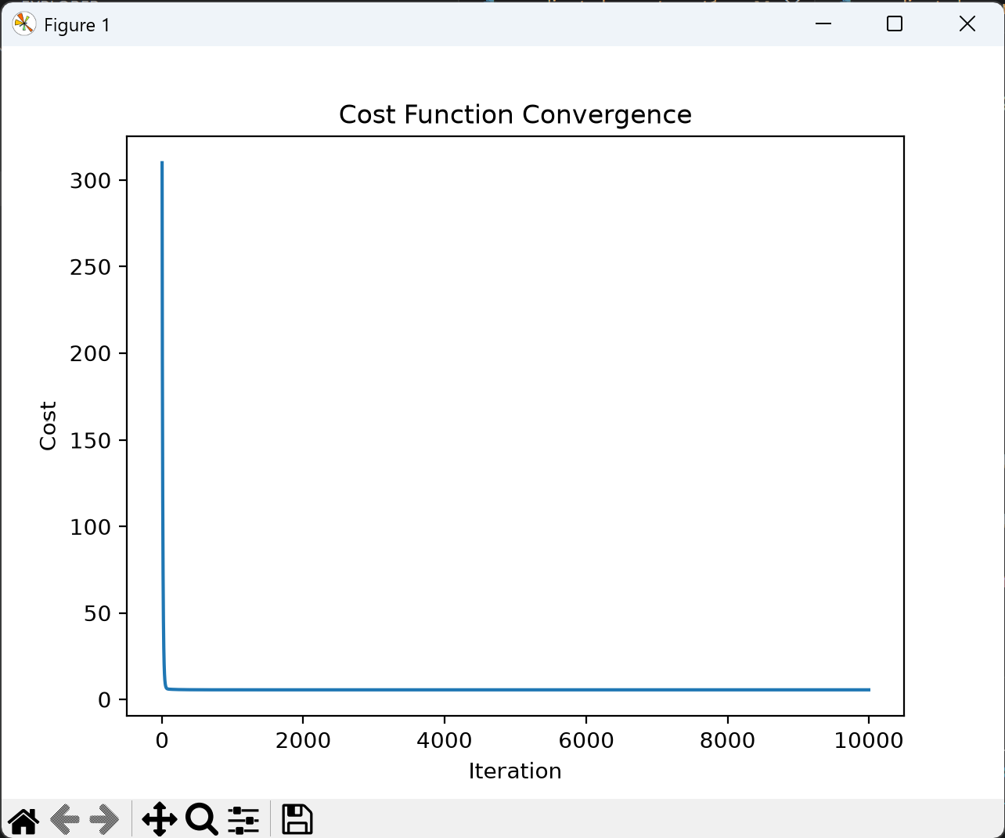

5. Part 2: SGDRegressor Implementation
Model
SGDRegressor from Scikit-Learn was used to perform linear regression using stochastic gradient descent.
Hyperparameter Tuning
Parameters Tested:
Learning Rate:
- 0.0001
- 0.001
- 0.01
- 0.05
Iterations:
- 1000
- 3000
- 5000
Alpha:
- 0.0001
- 0.001
Results were saved in:
sgd_regressor_tuning_log.csv
Best Model Results
MSE: 9.7522
RMSE: 3.1228
MAE: 2.2231
R² Score: 0.8089
Explained Variance: 0.8090
Coefficients
Feature 0: 1.2919
Feature 1: -0.2579
Feature 2: -0.7034
Feature 3: -4.8318
Feature 4: -0.0910
Feature 5: 2.6249
Feature 6: 1.0747
Intercept: 23.1497
Interpretation
The model achieved an R² score of 0.8089, indicating that approximately 80.89% of the variance in MPG is explained by the model. Weight was identified as the most influential feature with a strong negative coefficient. Model year showed a positive impact on fuel efficiency, indicating newer vehicles tend to achieve higher MPG values.

6. Evaluation Metrics
The following metrics were evaluated:
- Mean Squared Error (MSE)
- Root Mean Squared Error (RMSE)
- Mean Absolute Error (MAE)
- R² Score
- Explained Variance
- Feature Coefficients

- Plots
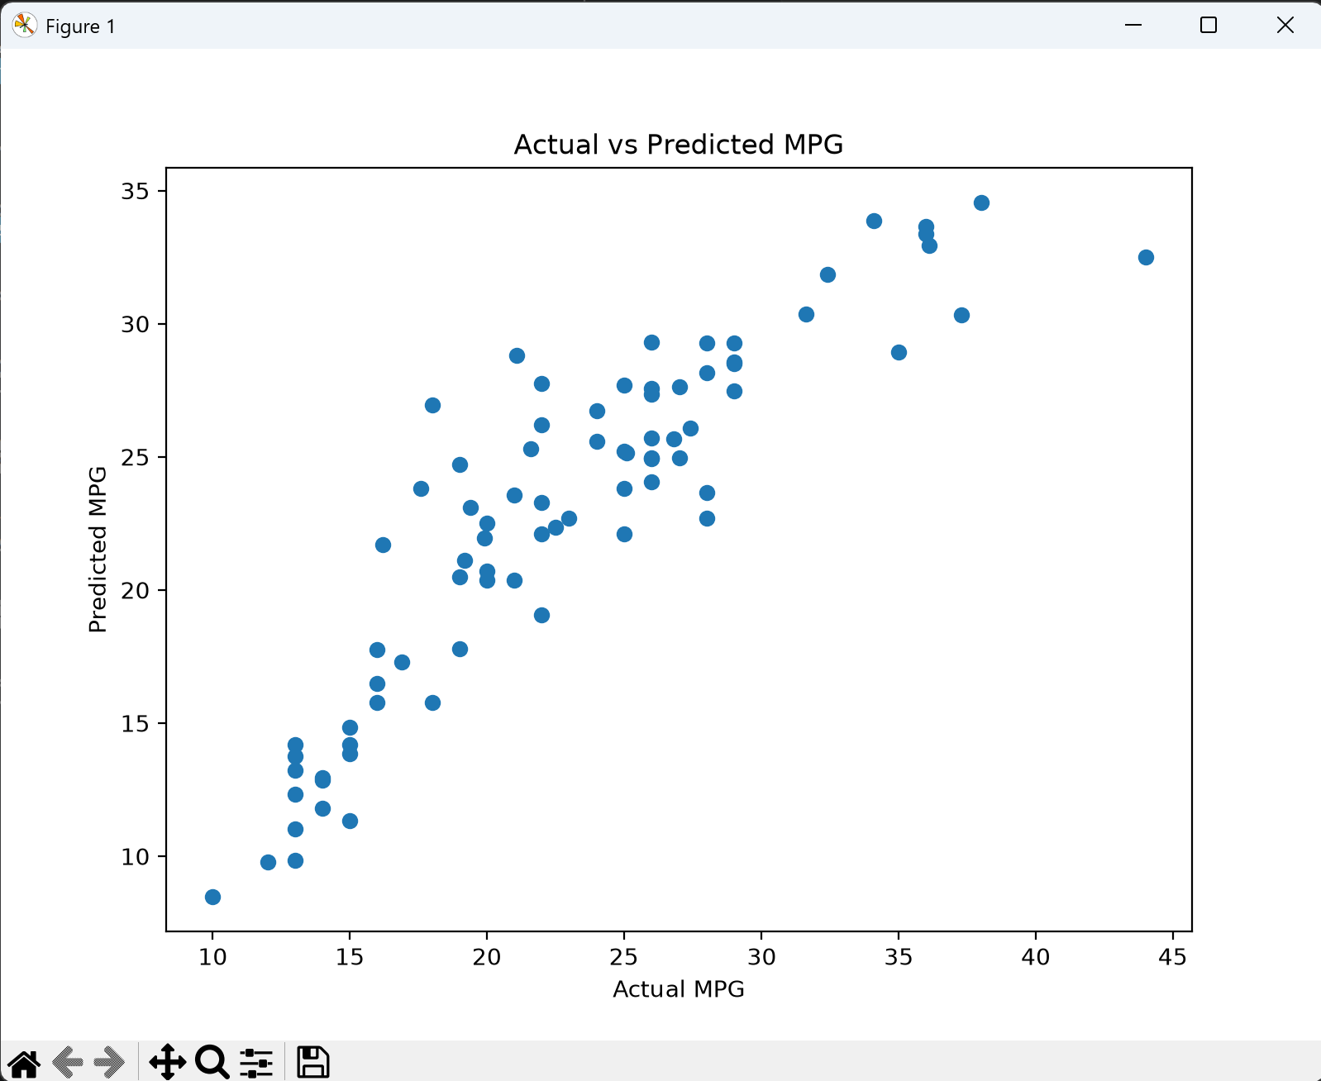

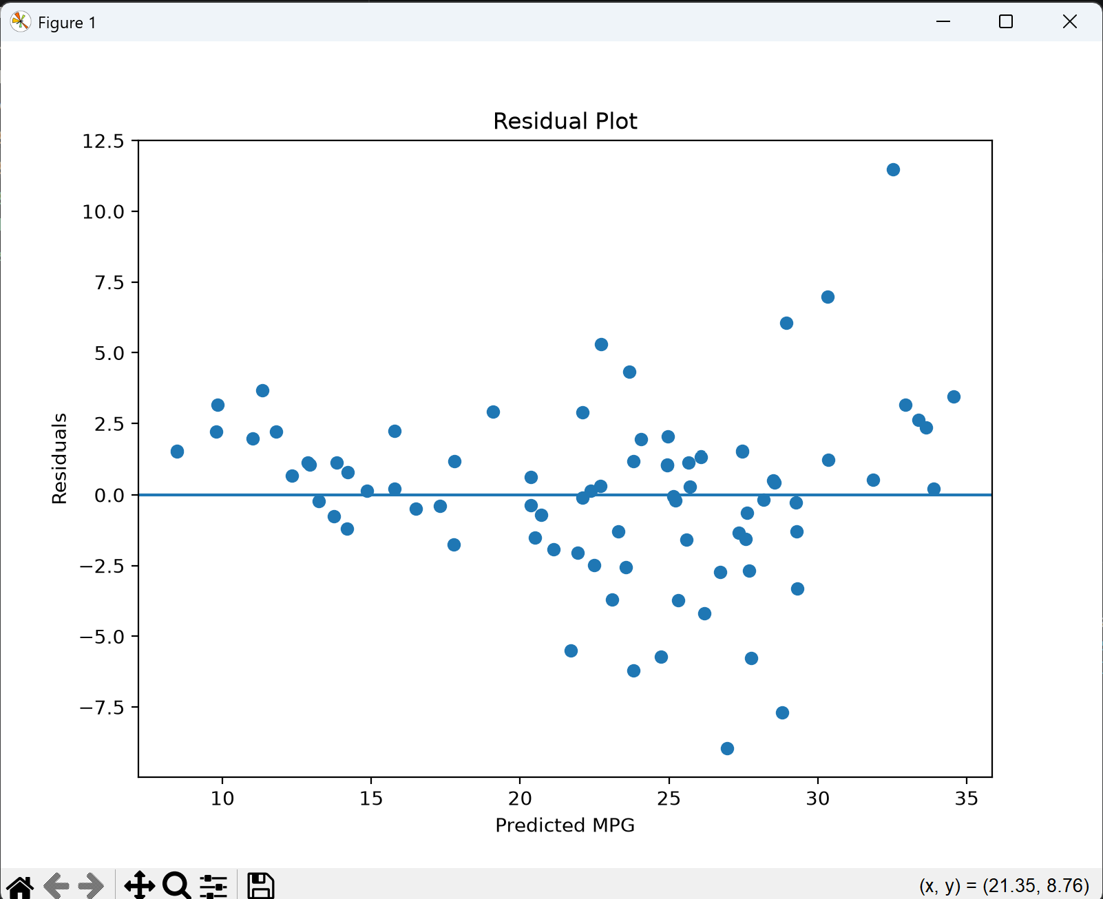

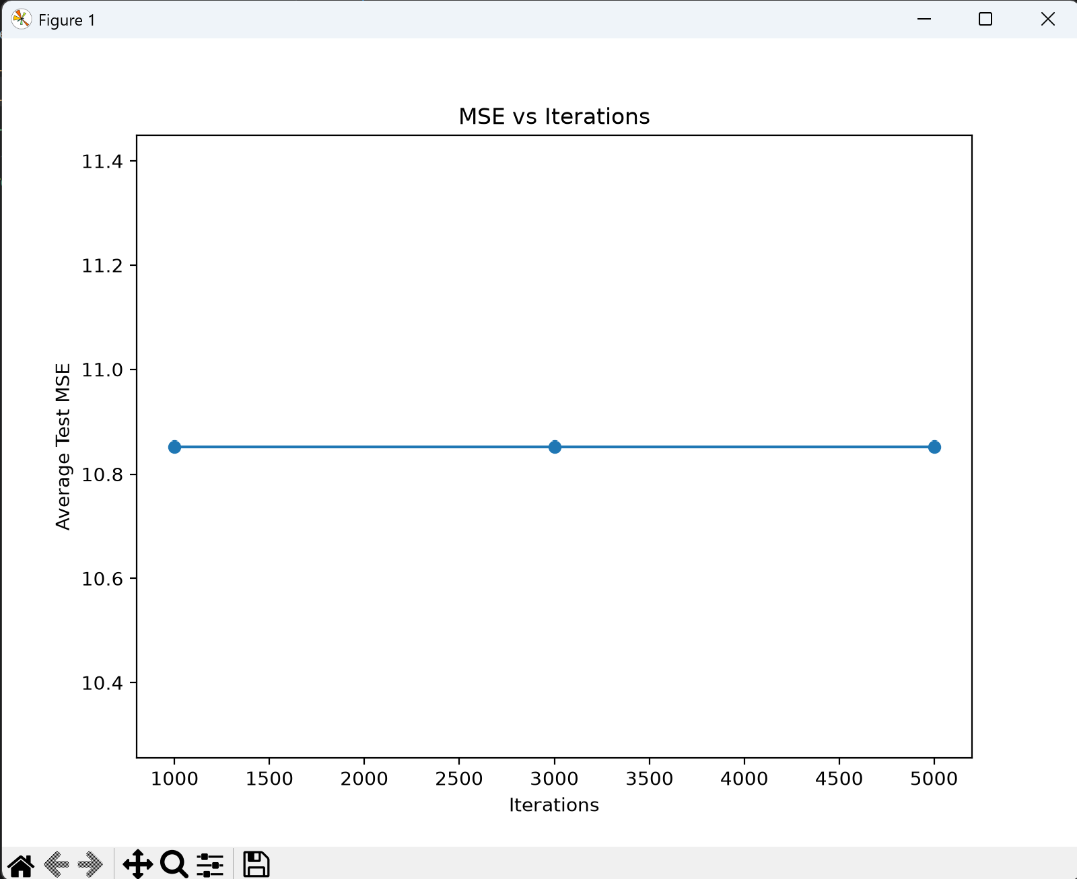

8. Conclusion
Both approaches successfully modeled the Auto MPG dataset. The custom implementation demonstrated the mechanics of gradient descent, while SGDRegressor provided a robust and optimized implementation. The best SGDRegressor model achieved an R² score of 0.8089, indicating strong predictive performance on the test dataset.

